**GCC Window setup for C**

* **Download & Install MinGW**
* **Add MinGW to PATH**

1. **Download and Install MinGW (Minimalist GNU for Windows)**
   1. Visit <https://sourceforge.net/projects/mingw/> and download, you will get *mingw-get-setup.exe*
   2. Double Click on executable

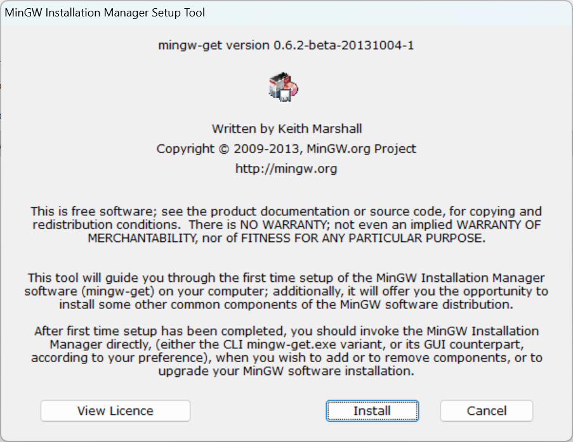

* 1. Click Install

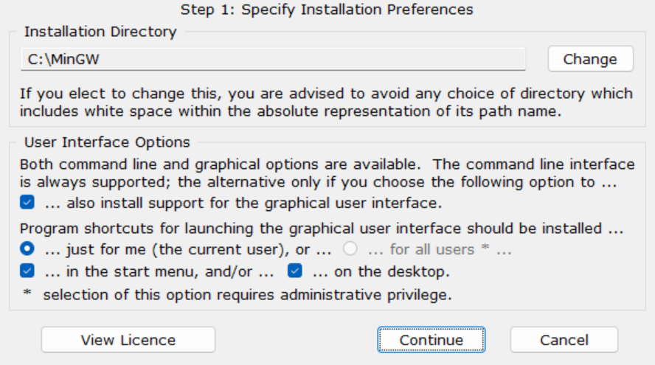

* 1. Continue

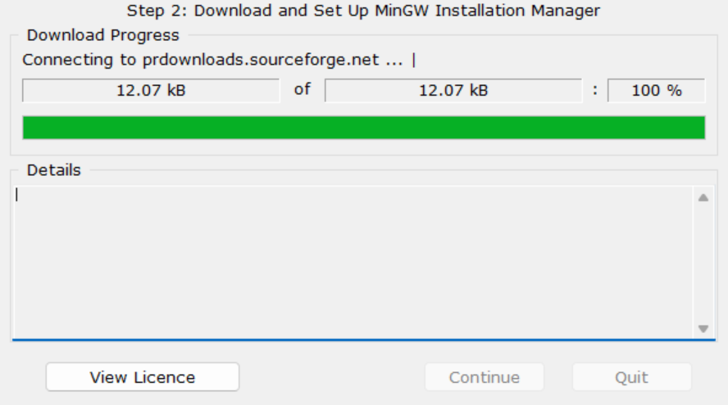

* 1. Continue

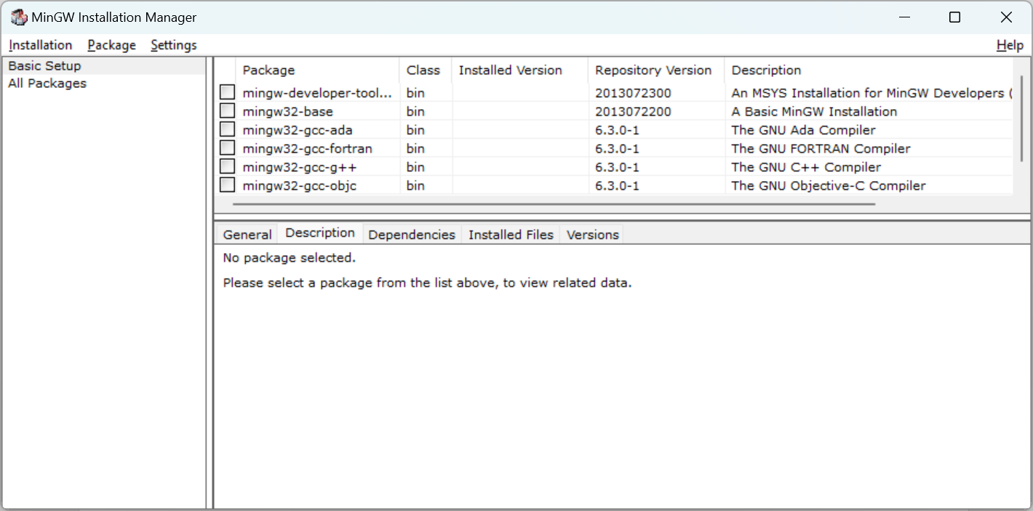

* 1. Select *mingw32-base* & *mingw32-gcc-g++*, Click on *Installation/Apply changes*

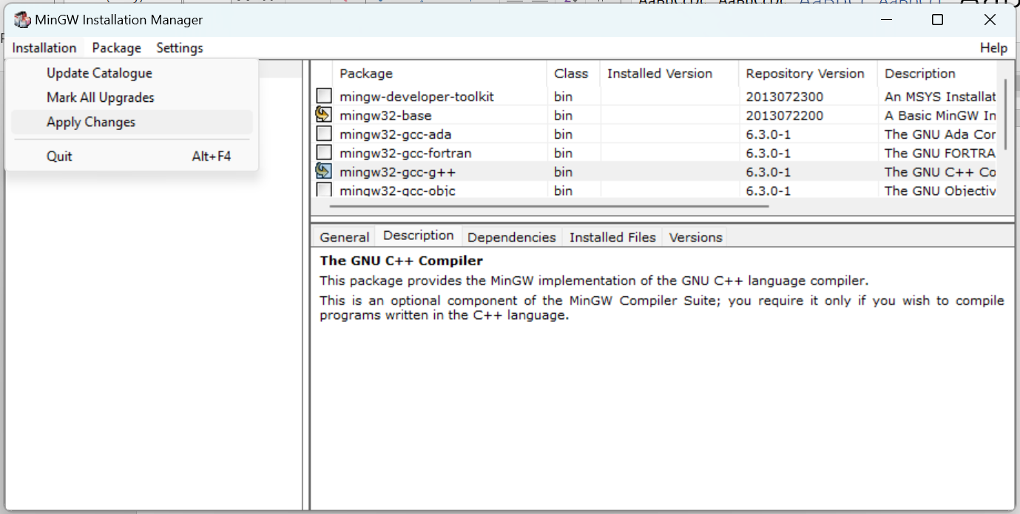

* 1. Click on Apply

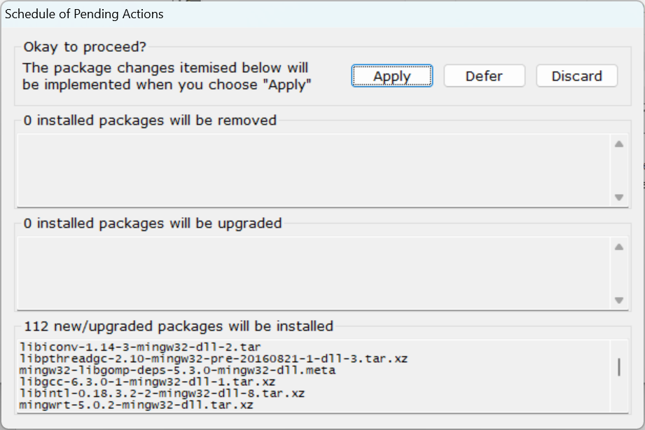

* 1. Installation is in progress

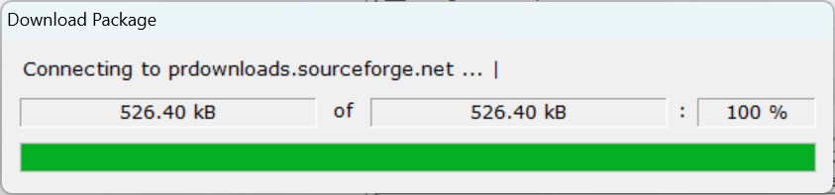

* 1. Final dialog , click Close & its done

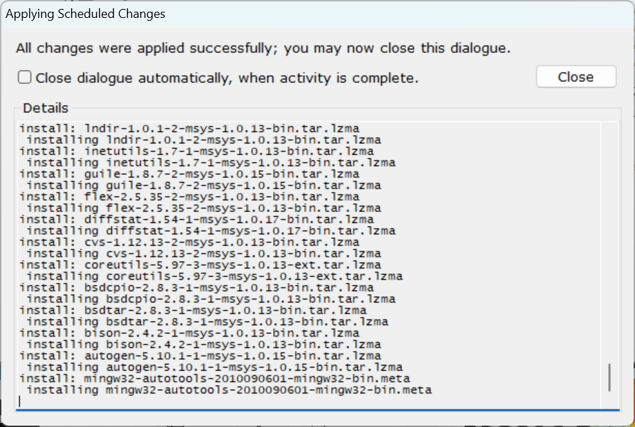

1. **Add MinGW to the environment variable - PATH** 
   1. Default MinGW installed to *C:\MinGW\bin*, if you have chosen to install to different location then copy the path till bin directory.
   2. Open *System Properties* (You can type “env” to search box and then click on the item “edit the System environment variables”)

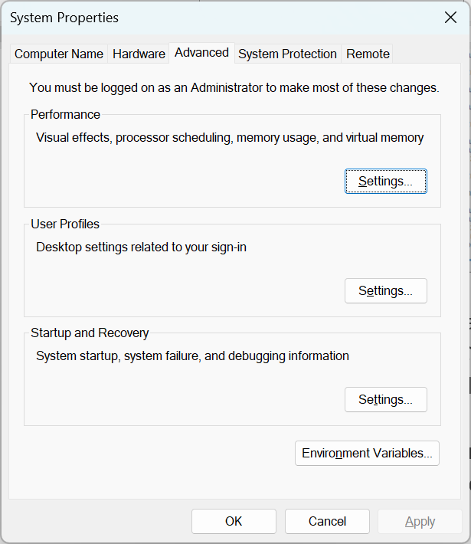

* 1. Under the tab *Advanced*, click *Environment Variables*

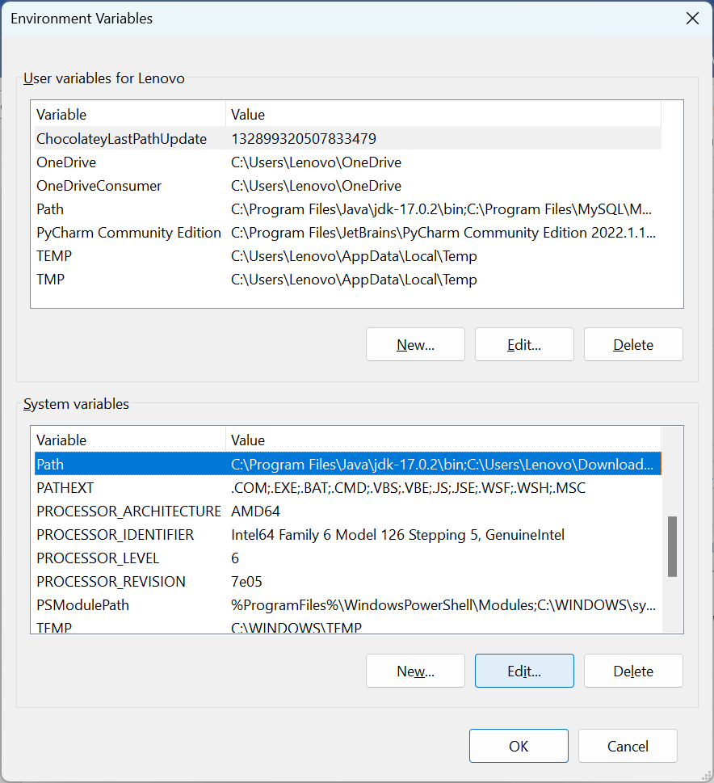

* 1. Select *Path* & Click on *Edit,* New dialog will open

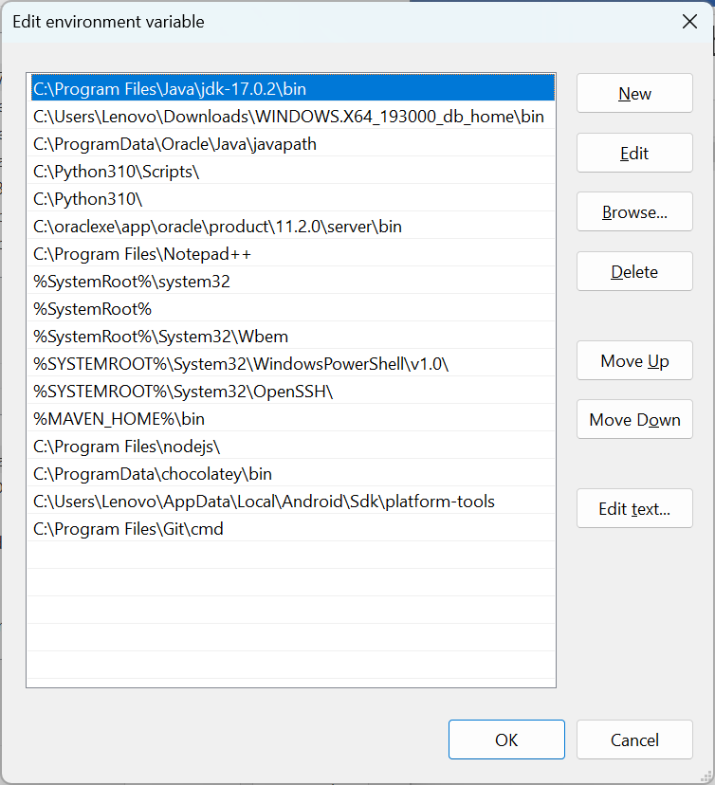

* 1. Click on *New* & add *C:\MinGW\bin.* Ok and close all dialogs.

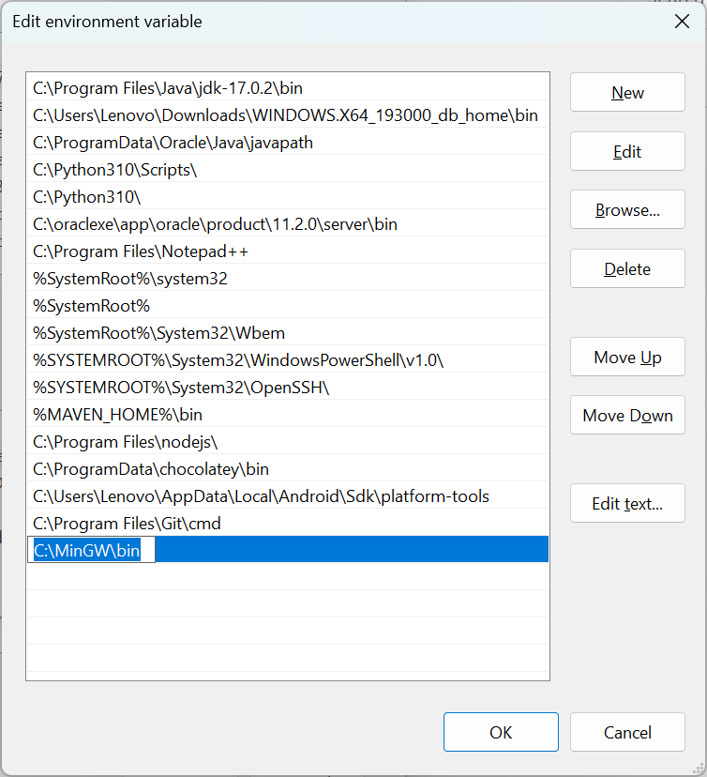

* 1. Done, verify the MinGW from command prompt

